|  |  |
| --- | --- |
| **DOKUMENTASI EKSTERNAL**  External Documentation |  |
| **[TUGAS ~~MANDIRI~~ / PROYEK]**  **[*~~Assignment~~ / Project*]** |
| **MATAKULIAH <COMP6176> – <Human & Computer Interaction>**  ***Subject*** |
| SEMESTER [~~GANJIL~~/GENAP/~~PENDEK~~] 2020/2021 ***[Odd/Even/Compact] Semester Year 9999/9999*** |

## Judul Proyek

*[Assignment / Project]**Title*

* **LaForant**

## Pendahuluan

*Introduction*

* **INTRODUCTION**

Laforant is a first-person shooter, in this game you will have face real time opponent from all over the world into a single battleground. The players will be set in a 5 vs 5 match using unique agents from different class. Each of the agents has their own special abilities and roles.

## Dokumentasi

*Report / Documentation*

* **REPORT / PRINT SCREEN & DESCRIPTION**
  + **HOMEPAGE BLUEPRINT**
    - Header



* + - Introduction

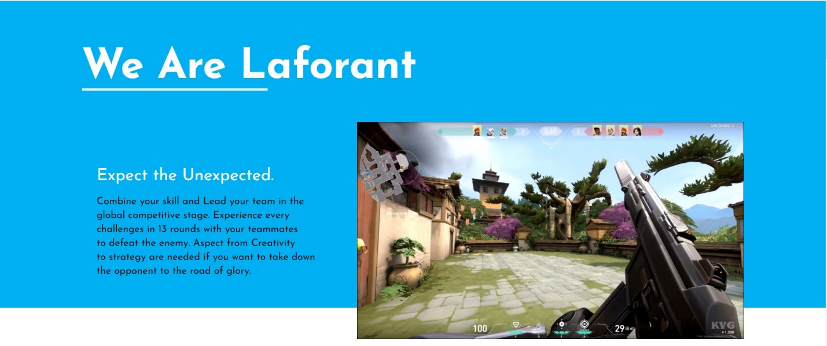

* + - Agents Preview

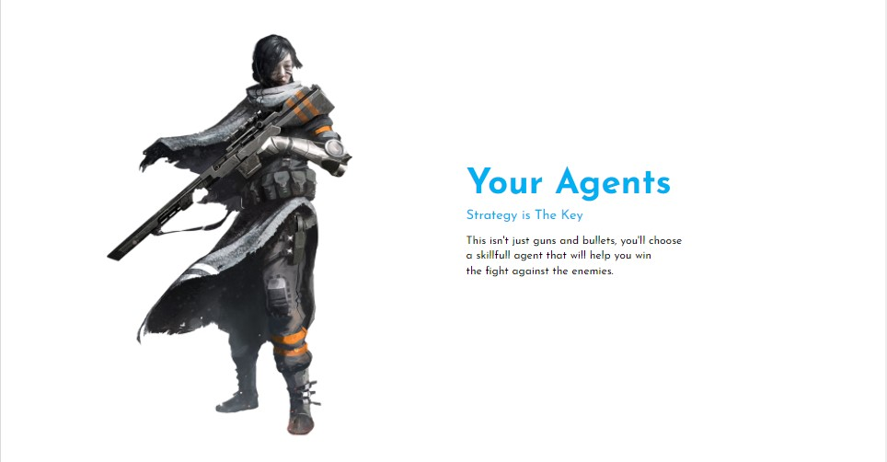

* + - Maps Preview

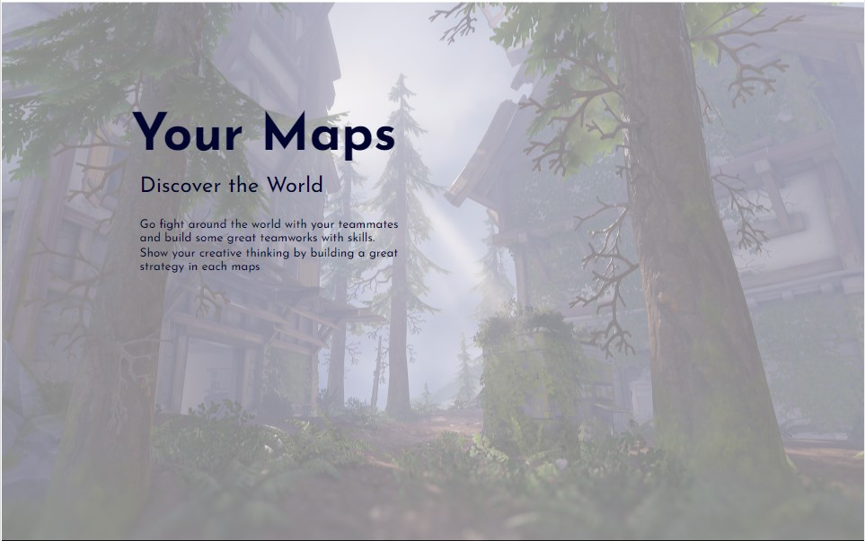

* + - Footer



* + **HOMEPAGE**

The Laforant Homepage is the first page that the user will see first. The homepage will be provided with introduction of our game and a quick summary of the agents and maps.

* + **AGENT**

In the Agent section, user will be introduced with the agents (the characters that will be playable on the game) of Laforant. It will be provided with the agent class, description, and their avatars.

* + **MAPS**

In the Map section, user will be introduced with the maps they will play on the game match.

* + **SYSTEM REQUIREMENT**

In the system requirement section, user can see the information about the minimum and recommended specs to play Laforant.

* + **PRE-REGISTER**

In the pre-register section, user will be provided with a form if they want to received news and the beta version of the game (early access) since this game is free to play.

**Referensi**

*References*

* **REFERENCES**
  + Homepage : <https://www.google.co.id/url?sa=i&url=https%3A%2F%2Fglavred.info%2Fua%2Ftechno%2Favtory-valorant-predstavili-novuyu-kartu-i-nagrady-boevogo-propuska-10267346.html&psig=AOvVaw0I0lOyCT5LwNUEfqAmQdWf&ust=1624390690822000&source=images&cd=vfe&ved=0CAoQjRxqFwoTCOi9tYO9qfECFQAAAAAdAAAAABAD> (Gameplay Image)
  + Agents:
    - <https://www.deviantart.com/thomaswievegg/art/Character-Concept-429393201> (Sledge)
    - <https://www.deviantart.com/happy-mutt/art/The-Soldier-Dusk-429175289> (Dusk)
    - <https://www.deviantart.com/sinto-risky/art/Countries-Germany-621561489> (Kreiger)
    - <https://www.deviantart.com/madspartan013/art/Blade-Dancer-511236850> (Muse)
    - <https://www.deviantart.com/subakzzang/art/personal-works-327876087> (Eve)
    - <https://www.deviantart.com/sinto-risky/art/Countries-Israel-667986870> (Pluton)
  + Maps:

* + - <https://static.playoverwatch.com/img/pages/maps/images/black-forest.jpg> (Deep Forest)
    - <https://wallpaperflare.com/hanamura-overwatch-video-games-cherry-blossom-blizzard-entertainment-wallpaper-urdqn> (Sakura Palace)
    - <https://br.pinterest.com/pin/97531148170337313/> (Ice Land)
    - <https://playoverwatch.com/en-us/maps/>
  + Icons:
    - <https://fontawesome.com/v4.7/cheatsheet/>
    - <https://www.google.co.id/url?sa=i&url=https%3A%2F%2Fwww.nmwa.go.jp%2Fen%2F&psig=AOvVaw2DxrdW_NAlmP1fXI4PSfvn&ust=1624391293489000&source=images&cd=vfe&ved=0CAoQjRxqFwoTCODbr6G_qfECFQAAAAAdAAAAABAD> (Facebook)
    - <https://www.google.co.id/url?sa=i&url=https%3A%2F%2Fwww.aupredeles2vaches.com%2F&psig=AOvVaw0vG5f1x2gm9i_omIoKydIr&ust=1624391335782000&source=images&cd=vfe&ved=0CAoQjRxqFwoTCJCzora_qfECFQAAAAAdAAAAABAI> (Instagram)
    - <https://www.google.co.id/url?sa=i&url=https%3A%2F%2Fwww.applikon-biotechnology.com%2Fen%2F&psig=AOvVaw2eKiDmB1ur25Lo274TLflI&ust=1624391383368000&source=images&cd=vfe&ved=0CAoQjRxqFwoTCMDLpsy_qfECFQAAAAAdAAAAABAD> (Twitter)
    - <https://www.google.co.id/url?sa=i&url=https%3A%2F%2Fwww.ecksplorer.com%2Fblog%2Feverything-you-need-to-know-about-a-layover-in-dubai&psig=AOvVaw2RumxDAXNBMRKBw1Ys7WjW&ust=1624391418386000&source=images&cd=vfe&ved=0CAoQjRxqFwoTCKDJkN6_qfECFQAAAAAdAAAAABAU(Youtube)>
    - <https://playvalorant.com/en-us/> (Riot Games)
  + Font: <https://fonts.google.com/specimen/Josefin+Sans?query=josefin> (Josefin Sans)
* **LINK**

Disiapkan Oleh,

*Prepared by,*

* **2440016533 – CHARLES SANTOSO**
* **2440005725 - ALEXANDER REYNALD**
* **2440015032 - RYAN VALDO**